Feed the penguin! build the dice, roll the dice and feed the penguin the matching fish.

Date completed:

Can you make a veggie superhero? Create a story about your Super Veggie!

Date completed:

Can you practice writing the letter ‘a’

Date completed:

**Mrs Marsland’s**

**Homework Challenges**

**Spring 1**

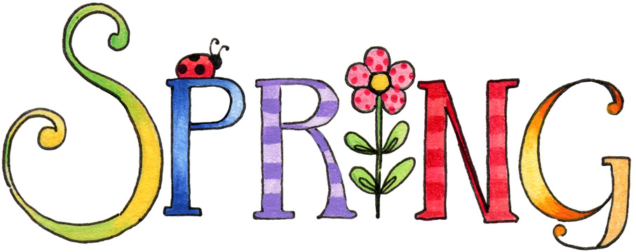

**Choose 1 challenge to do each week. Be as creative as you like in presenting how you attempted each challenge! Colour the box to show it has been done.**

Sound hunt! How many words can you find that have our new sounds in them.

Date completed:

Shape hunt! Look for 2D shapes when you are out and about. What shapes did you see?

Date completed:



Complete the word building activity!

Date completed:

Can you practice writing the letter ‘g’.

Date completed:

Play tricky word snakes and ladders. (You could do this more than once!)

Date completed:

Draw or paint a picture of your favourite superhero!

Date completed:

What vegetables do you like to eat? Make something delicious with your favourite vegetables!

Date completed: